**LCD (liquid crystal display)**

**INTRODUCTION:**

LCD (liquid crystal display) is the technology used for displays in notebook and other smaller computers. Like light-emitting diode (LED) and gas-plasma technologies, LCDs allow displays to be much thinner than cathode ray tube (CRT) technology. LCDs consume much less power than LED and gas-display displays because they work on the principle of blocking light rather than emitting it.

An LCD is made with either a passive matrix or an active matrix display grid. The active matrix LCD is also known as a thin film transistor (TFT) display. The passive matrix LCD has a grid of conductors with pixels located at each intersection in the grid. A current is sent across two conductors on the grid to control the light for any pixel. An active matrix has a transistor located at each pixel intersection, requiring less current to control the luminance of a pixel. For this reason, the current in an active matrix display can be switched on and off more frequently; improving the screen refresh time (your mouse will appear to move more smoothly across the screen, for example).

Some passive matrix LCD's have dual scanning, meaning that they scan the grid twice with current in the same time that it took for one scan in the original technology. However, active matrix is still a superior technology.

**HISTORY OF LCD:**

In 1888, liquid crystals were first discovered in cholesterol extracted from carrots by Austrian botanist and chemist, Friedrich Reinitzer.

In 1962, RCA researcher Richard Williams generated stripe-patterns in a thin layer of liquid crystal material by the application of a voltage. This effect is based on an electro-hydrodynamic instability forming what is now called “Williams domains” inside the liquid crystal.

According to the IEEE, "Between 1964 and 1968, at the RCA David Sarnoff Research Center in Princeton, New Jersey, a team of engineers and scientists led by [George Heilmeier](http://web.mit.edu/invent/iow/heilmeier.html) with Louis Zanoni and Lucian Barton, devised a method for electronic control of light reflected from liquid crystals and demonstrated the first liquid crystal display. Their work launched a global industry that now produces millions of LCDs."

Heilmeier's liquid crystal displays used what he called DSM or dynamic scattering method, wherein an electrical charge is applied which rearranges the molecules so that they scatter light.

The DSM design worked poorly and proved to be too power hungry and was replaced by an improved version, which used the twisted nematic field effect of liquid crystals invented by James Fergason in 1969.

### **James Fergason**

Inventor, James Fergason holds some of the fundamental patents in liquid crystal displays filed in the early 1970's, including key US patent number 3,731,986 for "Display Devices Utilizing Liquid Crystal Light Modulation". In 1972, the International Liquid Crystal Company (ILIXCO) owned by James Fergason produced the first modern LCD watch based on James Fergason's patent.

**TYPES OF LCD:**

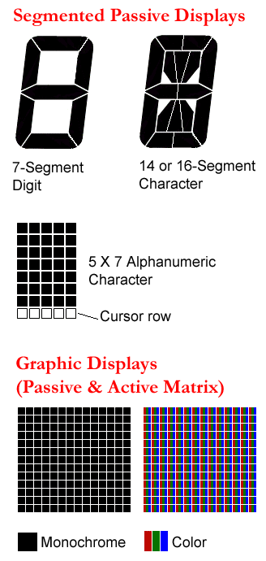

**KINDS OF TECHNOLOGY:**

Segmented characters (top) are used for small readouts, while the 5x7 matrix (middle) provides more character design flexibility. TVs, computer screens and mobiles use a matrix of thousands of rows and columns (bottom). In both active and passive methods, the matrix is addressed one row at a time for each frame.

**Passive Displays**

Passive displays are widely used with segmented digits and characters for small readouts in devices such as calculators, printers and remote controls, many of which are monochrome or have only a few colors. Passive monochrome and color graphics displays were used in the first laptops, and they are still used as an alternative to active matrix.

Passive matrix is less costly because transistors are used to activate rows and columns, not each sub pixel, resulting in fewer manufacturing steps (see Active Matrix Displays below). However, passive matrix screens have a narrower viewing angle and suffer from "submarining," which is the disappearance of the cursor when moved quickly.

* **TN - Twisted Nematic (90º Twist)**

The first LCD type, TN is used in low-cost readouts for consumer products, and it is also the foundation for color active matrix.

* **STN - Super twisted Nematic (240-270º Twist)**

Widely used in the past, STN LCDs use birefringence to absorb and pass selective light wavelengths.

* **FSTN - "Film Compensated" STN**

Widely used for passive color matrix screens, an optical film layer turns the STN color into a neutral density light source (a "light valve"). Red, green and blue filters are added for full color.

* **DSTN - "Double Layer" STN**

Used in high-temperature environments, a second, but inactive, LCD layer functions like the film in FSTN, except that the layer's optical properties change at the same rate as the working layer. DSTN used to mean "dual scan" STN, which enabled higher laptop resolution by addressing two modules simultaneously; for example, two 240-line passive matrix subsystems created 480 lines.

* **ESTN and ISTN**

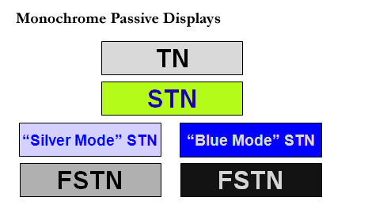Proprietary STN displays from Varitronix.

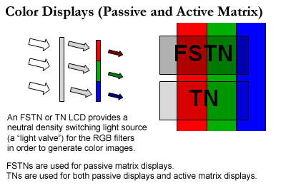

**LCD Screen Colors:**

Passive displays are monochrome TN, STN and FSTN, and passive color displays are TN and FSTN. Active matrix displays are color TN.

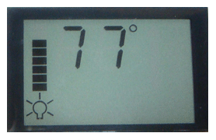

**Custom Design**

Passive displays are created for custom applications. This ceiling fan readout uses segmented digits for temperature and custom elements for the lights.

**Active Matrix Displays (TFTs)**

Unlike passive matrix LCDs, active matrix displays have a transistor at each red, green and blue sub pixel that keeps them at the desired intensity until that row is addressed in the next frame.

**More Contrast, Sharper, Faster and Brighter**

By driving the sub pixels independently, active matrix screens are sharper and have more contrast than passive matrix, and their faster response times eliminate submarining. In addition, active matrix screens are very bright indoors because they use a backlight (see LCD and LCD example); witness the extraordinary computer screens and HDTV sets on the market. However, when active matrix cellphones and laptops are taken into bright sunlight, they can be overwhelmed with reflected ambient light and difficult to read.

**High-End Displays Are Active Matrix**

In the early days of laptops, active matrix cost a lot more than passive, and both types were offered. Today, color active matrix is the only type of LCD used in LCD/LED TVs, computer and LCD mobile screens. Also called a "thin film transistor LCD" (TFT LCD), a thin layer of transistors is deposited on the back of the screen (see amorphous silicon). Active matrix uses TN liquid crystals with a 90º twist. See bad pixel and LCD.

**ADVANTAGES:**

1. Very little heat emitted during operation, due to low power consumption**.**
2. No geometric distortion.
3. The possible ability to have little or no "flicker" depending on backlight technology. Usually no refresh-rate flicker, because the LCD pixels hold their state between refreshes

**DISADVANTAGES:**

1. Uneven backlighting in some (mostly older) monitors, causing brightness distortion, especially toward the edges.
2. Loss of contrast in high temperature environments.
3. Not usually designed to allow easy replacement of the backlight.
4. Cannot be used with light guns/pens.
5. Hard to read when wearing polarized sunglasses.

**LIMITATIONS:**

Resolutions: Works best at the native resolution. The native resolution cannot be changed. All other resolutions require adjusting procedures which can cause considerable deterioration of the image.

**Terminologies:**

**Overlays file system:**

An overlay-file system tries to present a file system which is the result over overlaying one file system on top of the other. Overlays allow one, usually read-write, directory tree to be overlaid onto another, read-only directory tree. All modifications go to the upper, writable layer. This type of mechanism is most often used for live CDs but there's a wide variety of other uses.

**Raster scanning:**

Raster scanning is the process of displaying an image by updating each pixel one after the other, rather than all at the same time, with all the pixels on the display updated over the course of one frame.

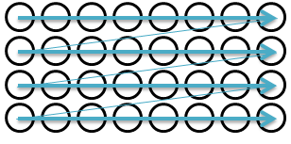

**Resolution:**

Resolution is the number of pixels (individual points of color) contained on a display monitor, expressed in terms of the number of pixels on the horizontal axis and the number on the vertical axis. The sharpness of the image on a display depends on the resolution and the size of the monitor. The same pixel resolution will be sharper on a smaller monitor and gradually lose sharpness on larger monitors because the same numbers of pixels are being spread out over a larger number of inches.

**Pixel:**

A pixel is the smallest element of an image. We also define that a pixel can store a value proportional to the light intensity at that particular location.

**How colored pixels work LCD**

There's a bright light at the back of touch screen, there are lots of colored squares flickering on and off at the front. How each colored pixel is switched on or off?

**How pixels are switched off:**

1. Light travels from the back of the LCD display toward the front from a large bright light.
2. A horizontal polarizing filter in front of the light blocks out all light waves except those vibrating horizontally.
3. Only light waves vibrating horizontally can get through.
4. A transistor switches off this pixel by switching on the electricity flowing through its liquid crystal. That makes the crystal straighten out (so it's completely untwisted), and the light travels straight through it unchanged.
5. Light waves emerge from the liquid crystal still vibrating horizontally.
6. A vertical polarizing filter in front of the liquid crystal blocks out all light waves except those vibrating vertically. The horizontally vibrating light that travelled through the liquid crystal cannot get through the vertical filter.
7. No light reaches the screen at this point. In other words, this pixel is dark.

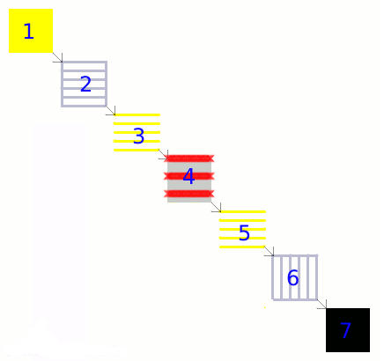

**How pixels are switched on:**

1. The bright light at the back of the screen shines as before.
2. The horizontal polarizing filter in front of the light blocks out all light waves except those vibrating horizontally.
3. Only light waves vibrating horizontally can get through.
4. A transistor switches on this pixel by switching off the electricity flowing through its liquid crystal. That makes the crystal twist. The twisted crystal rotates light waves by 90° as they travel through it.
5. Light waves that entered the liquid crystal vibrating horizontally emerge from it vibrating vertically.
6. The vertical polarizing filter in front of the liquid crystal blocks out all light waves except those vibrating vertically. The vertically vibrating light that emerged from the liquid crystal can now get through the vertical filter.
7. The pixel is lit up. A red, blue, or green filter gives the pixel its color.

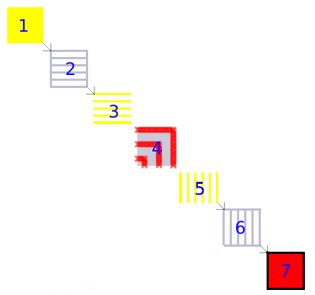

**How LCD display use liquid crystals and polarized light:**

An LCD screen uses the sunglasses trick to switch its colored pixels on or off. At the back of the screen, there's a large bright light that shines out toward the viewer. In front of this, there are the millions of pixels, each one made up of smaller areas called sub-pixels that are colored red, blue, or green. Each pixel has a polarizing glass filter behind it and another one in front of it at 90 degrees. That means the pixel normally looks dark. In between the two polarizing filters there's a tiny twisted, nematic liquid crystal that can be switched on or off (twisted or untwisted) electronically. When it's switched off, it rotates the light passing through it through 90 degrees, effectively allowing light to flow through the two polarizing filters and making the pixel look bright. When it's switched on, it doesn't rotate the light, which is blocked by one of the polarizers, and the pixel looks dark. Each pixel is controlled by a separate transistor (a tiny electronic component) that can switch it on or off many times each second.

**How to interface LCD MODULE with AM335x :**

RGB

LCD

AM335X